AIR FORCE JUNIOR ROTC
NC-944 GUIDEBOOK
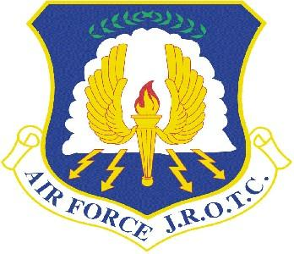

CAO 4 APR 2024

This guidebook is in effect until superseded. It supersedes all previous AFJROTC guides.
This guidebook was adapted from HQ AFJROTC cadet reference guide.

Introduction

Welcome to AFJROTC NC-944! We are glad that you have chosen to be a part of this dedicated unit. As an AFJROTC cadet you will be expected to hold yourself to a higher standard than your peers. In order to identify and comply with the standards required of an AFJROTC cadet in this unit, the NC-944 Guidebook is provided as a resource to ensure your success.

Additionally, this handbook provides guidance on goal setting, planning and executing cadet programs, promotions, discipline, expectations and awards. It also provides information on several special programs and Leadership Development activities sponsored by NC-944.

Congratulations on your decision to join AFJROTC!

Table of Contents

Cadet Creed……………………………………………………………………………………………………………………………….4
Section 1: Cadet Strategic planning and goal setting process……….…………………………………………….5
Using and Documenting Goal Accomplishment……………………………………………….….….………6
Strategic Goals from SY2024……………………………………………………………….…….……………………7
Cadet-Run Operational & Functional Areas Of Responsibility……..………………………………….8
Community Service………………………………………………………………..………………………………..…..13 Section 2: Cadet Enrollment and Disenrollment………………………………………………………….……………14
Section 3: Wear and Care of the Air Force Uniform………………………………………………………………….15
Cadet Female Appearance and Grooming Guidelines:…………………………………….…….……..18
Cadet Male Appearance and Grooming Guidelines:………………………….……..…………….…….23
Uniform wear rubric:……………………………………………………….…………………………………….…….25
Section 4: Wellness/Physical Training (PT) …………………………………………………………………………….…25
Section 5: Program Opportunities & LDR Activities……………………………………………………………….....25
What a typical week in NC-944 looks like………………………………………………………..……………26
Additional LDR activities..………….…………………………………………………….…………..………………26
Section 6: Planning and Executing Cadet Operations & Programs…………………………….……………...27
Replica weapons policy………………………………………………………………………………..………………28
Cadet Rank, Promotions and Awards…………………………………………………………………………………….…28 Specific Insignia (Rank) Placement …………………………………………………………………………….…29
Common errors in rank placement:………………………………………………………………………………30
Section 7: Cadet Discipline………………….…..……………………………………………………………………………….31 Hazing and Physical Discipline Prohibitions:…………………………………………………………….……31
Section 8: Corps Excellence…………………….………………………………………………………………………….…….32 After Action Reports………………….………………………………………………….………………………………….………32
Section 9: Reserve Cadets……….……….……………………………………………………………………………….……..33 Section 10: Cell Phone Policy…………………………………………………………………………………………….……..33
Attachments:
- Cadet ABU Guidance:……………………………………………………………………………………………………34
- Lightweight Blue Jacket:………………………………………………………………….…………..……….………35
- Male Service Dress:………………………………………………………………………………………………………36
- Female Service Dress:……………………………………………………………..……………………………………37
- Male Blue Shirt:……………………………………………………………………………….…………………….…….38
- Female Blue Shirt:………………………..………………………………………………………………………………39
- Ribbon AFJROTC Ribbon Chart:……………………………………………………………………….……………40
- Shoulder Cord Policy..………………………………………………………………………………………………….41

AFJROTC Cadet Creed

I am an Air Force Junior ROTC Cadet.
I am connected and faithful to every Corps of Cadets who served their community and nation with patriotism.
I earn respect when I uphold the Core Values of Integrity First, Service Before Self, and Excellence In All We Do.
I will always conduct myself to bring credit to my family, school, Corps of Cadets, community, and to myself.
My character defines me. I will not lie, cheat, or steal. I am accountable for my actions and deeds.
I will hold others accountable for their actions as well. I will honor those I serve with, those who have gone before me, and those who will come after me.
I am a Patriot, a Leader, and a Wingman devoted to those I follow, serve, and lead.
I am an Air Force Junior ROTC Cadet.

Back to Table of Contents

FOREWORD

Air Force Junior Reserve Officer Training Course (AFJROTC) is designed to foster citizenship, leadership and followership. Students are expected to exhibit appropriate behavior at all times. This means not being disruptive in the classroom, following the instructions of the teachers and student leadership and leading when the situation calls for it. AFJROTC is an elective course. Following the guidelines listed in this document will set you up to succeed in this course.

In order to maintain the high standards of courtesy, personal conduct and appearance required by the USAF and Northern High School, the student is expected to take proper care of all materials provided by the Air Force and to return them when required. Cadets are taught basic military skills associated with drill and ceremonies and are expected to respond positively to other cadets who have been appointed to leadership positions in the cadet corps. Cadets in leadership positions are expected to conduct themselves with utmost professionalism. They should demonstrate self-discipline, responsibility and accountability for their actions.

This guide provides a reference on how to build a strong cadet corps with cadet leaders that fully own their unit through setting organizational goals; developing programs to support those goals; planning and executing their programs; measuring, monitoring, recording and reporting progress toward the unit goals; and operating and controlling the functional areas of day-to-day unit operations.
Note: Following the significant attrition of senior-level cadets during and immediately following the COVID-19 pandemic, NC-944 is in the process of rebuilding cadet leadership skills in order to facilitate full cadet ownership of unit programs and operations. Those cadets willing to embrace leadership roles during this transition period, will most likely encounter challenging but very rewarding opportunities!

Section 1:Cadet Strategic Planning and Goal Setting Process

Headquarters (HQ) AFJROTC requires all units to specify a minimum of six organizational goals that support the mission: “Develop citizens of character, dedicated to serving their nation and community.” Although six goals must be created and submitted through the HQ AFJROTC database, WINGS, there is no set limit to the number of goals cadets may pursue. The six HQ AFJROTC-required goals are divided into three broad categories: two goals are related to the cadet corps itself, two related to the school, and two related to the local community. Unit goals should be developed by the cadet corps with guidance from the AFJROTC instructors.

The Goal setting process may involve:
STEP 1: Know the goal setting process
STEP 2: Brainstorm ideas for the goals
STEP 3: Write the goals
Written goals should incorporate several essential components using the SMART acronym: Specific, Measurable, require Action or effort, be Realistic, and have a Time constraint.
STEP 4: Refine and submit the goals
The identified goals must be submitted to HQ AFJROTC by 10 Oct each year.
STEP 5: Measure goal accomplishment
The results of the six required goals must be reported to HQ AFJROTC by 10 April each year.

Using and Documenting Goal Accomplishment

At the beginning of the School Year (SY), AFJROTC students participate in a strategic planning process which involves conducting an Environmental Scan, identifying Strengths, Weaknesses, Opportunities and Threats, as well as reviewing goals and goal outcomes from the previous SY. Cadets then engage in individual and group processes to identify and determine the goals to work on for the current SY. Cadet corps goals are meant to guide both the cadets’ and NC-944’s performance. Goals are emphasized to ensure all program elements support cadet achievement. At least quarterly, progress toward goal attainment is updated to ensure the unit is headed in the right direction. Records are kept of the measurements for each goal and maintained in a format such as a computer spreadsheet or other approved document. Recommendations for improvements or adjustments to the goals are identified to assist the unit in meeting desired objectives. Cadet leaders should plan activities for the year in accordance with the established goals.

In order to ensure that NC-944 is in alignment with the vision and mission of Northern High School (NHS), the cadets use the NHS vision and mission statements to guide the strategic planning process. The NHS vision is as follows:
Our Vision:
At Northern High School, home of the KNIGHTS, we are passionate, dedicated, and UKnighted in helping all students:
Acquire Knowledge
Make No Excuses
Possess Integrity
On-Time Graduate
Meet High Expectations
Be A Team Player
Achieve Success In All Areas

Northern High School Mission Statement:
The NHS family is UKnighted in empowering its teachers, parents, and students in providing a learning environment that develops 21st century learners who maximize their potential through rigor, collaboration, and celebration of diversity.

Back to Table of Contents

NC-944 SY 2024 Strategic Goals

School Impact Goal 1: Conduct AFJROTC recruiting events at feeder middle schools 3X/SY 2024 & at NHS 3X/SY 2024.

School Impact Goal 2: Achieve first-year cadet course pass rate of 90% at the end of each semester.

Community Impact Goal 1: Complete a minimum of 2 community service projects by 10 April 2024.

Community Impact Goal 2: Achieve overall cadet corps participation in SY 24 community service, recruiting and other Leadership Development activities with 50% of cadets averaging at least 2 activity hours.

Cadet Impact Goal 1: Achieve 20% of cadet corps scoring above the 25th percentile for mile-run times at the end of each semester in SY 2024

Cadet Impact Goal 2: Achieve 60% of cadet corps completing and/or submitting on-line weekly fitness tracking logs for at least 6 weeks during each semester.

Cadet-Run Operational & Functional Areas Of Responsibility

Note: Some of the functions described in this section may not be currently implemented due to the rebuilding of cadet leadership capabilities following COVID-19 pandemic.

In a “cadet-owned” program, the cadet leadership is responsible for leading and maintaining all unit operations and functional areas. These areas of responsibility include (but are not limited to) logistics inventory control and record keeping, and cadet personnel records maintenance. Records maintenance includes: keeping unit records on community service, health and wellness activity documentation, and individual participation in Leadership Development Requirement (LDR) activities. Cadets utilize WINGS (under direct instructor supervision) to manage and operate the functional areas. The corps commander selects the key staff members for each functional area. The Aerospace Science Instructor (ASI)/Senior Aerospace Science Instructor (SASI) monitor this process to make sure the commander’s selections are within the ability of the cadet being selected. All selections are subject to approval by the SASI.

CADET RESPONSIBILITY: Each cadet will abide by the rules and regulations of the Aerospace Science Department and accept responsibility for the proper care and maintenance of their uniforms (not applicable to first-year cadets opting out of uniform wear), textbooks, and any other AFJROTC equipment.

OFFICER/NCO RESPONSIBILITIES: A cadet OFFICER or NCO has special leadership responsibilities. They are held to higher standards than other cadets and are expected to set a positive example in all actions. Among other general responsibilities to maintain rank/position, cadet officers and NCOs are expected to take the initiative when leadership action is needed to ensure the unit mission is successfully accomplished. This includes taking an active role in team activities and assisting other cadets as needed.

GENERAL CLASSROOM RESPONSIBILITIES:
Before School: Cadets may come to the classroom before school hours; however, no “horseplay” is allowed AT ANY TIME. Cadets will remain in the classroom or return to the Commons area; loitering is not allowed outside the classroom or in the hallways.
During the school day: Normally, cadets will NOT come to the AFJROTC classroom unless they have pre-coordinated with the SASI/ASI to work on a specific project and have a valid pass from their teacher for that class period. If allowed, the cadet must be respectable and not interfere with classroom activities.
Lunch: The cadet classroom is “OPEN” for cadet use during the lunch periods any day when the instructors are present and not assigned to Lunch Duty.
After School: Only cadets involved in after-school AFJROTC activities should be in the classroom after school.
Other Behavioral Expectations: Additional classroom behavioral expectations are listed in the syllabus for each Aerospace Science class. The syllabus is available to all cadets via the Canvas online learning platform.

CORPS MANAGEMENT AND JOB DESCRIPTIONS

As with the active Air Force, responsibilities and duties increase with grade and rank. Each cadet is expected to prepare for assuming additional responsibilities to accept higher positions. The following job descriptions outline the major duties of potential leadership positions contained within NC-944 (not all positions may be needed or feasible based on the size or interests of the cadet corps).
Cadets will use the established electronic media for official business related to the corps. The top senior staff along with the SASI and ASI will be the only ones to have the login username and password. All other cadet positions will be granted access to their specific continuity folder on the drive. All permissions and login information will be changed annually upon changeover of the cadet staff.

Note: Some of the functions and/or positions described in this section have not been currently implemented due to the rebuilding of cadet leadership capabilities following the COVID-19 pandemic. The positions currently implemented have been highlighted in bold print.

CADET CORPS COMMANDER (CC). Authorized Grade: c/Captain. Responsible for:
- Command and control of the cadet corps. Will establish and maintain a master calendar of all activities for the school year.
- The appearance, discipline, efficiency, training, and conduct of the corps.
- Overseeing cadet corps activities according to established cadet goals.
- Conducting at least two staff meetings per month for the improvement of the cadet corps operations and activities.
- Developing cadet goals for the school year and implementing a course of action to accomplish those goals.
- Other duties as assigned by the SASI/ASI.

CADET DEPUTY COMMANDER (CD). Auth. Grade: c/1st Lt. is a member of the Cadet Corps Staff.
Supervises cadets assigned as flight commanders. Responsible for:
- Assuming command of the unit in the absence of the Cadet Corps Commander as directed by the SASI/ASI. Will conduct unit staff meetings in the commander’s absence.
- Assisting the Cadet Corps Commander as requested by the commander and directed by the SASI/ASI.
- Developing and coordinating the unit staff meeting agenda with the commander.
- Keeping the commander informed of all cadet activities.
- Other duties as assigned by the commander or SASI/ASI.

FIRST SERGEANT (CCF). Auth. Maximum Grade: C/SMSgt. is a member of the Cadet Corps Staff.
Although not involved in direct supervision, this is a highly prestigious and selective position.

Responsible for:
- Keeping the commander informed on matters of drill, weekly uniform wear, and conduct of cadets. Updating the daily briefing with upcoming uniform inspections.
- Updating information to the corps on AFJROTC regulations concerning uniform wear, standards of conduct, customs, and courtesies.
- Maintaining a high degree of personal military bearing and appearance. Serves as an example for the entire cadet corps.
- Monitoring morale and welfare of members of the cadet corps and recommending solutions to problems concerning these issues to the commander.
- Delivering inspirational messages as required at corps activities.
- Performs required duties related to the cadet/flight of the month/semester.
- Other duties as assigned by the commander or the SASI/ASI.

PUBLIC AFFAIRS OFFICER (PA). Auth. Grade: C/2Lt. is a member of the Cadet Corps Staff.
Supervises the Public Affairs NCOIC. Responsible for:
- Coordinating all matters of AFJROTC publicity with the Commander and the SASI/ASI.
- Coordinating with the school library staff regarding AFJROTC publicity on morning announcements and slides.
- Preparing appropriate publicity as follows:
–Performing duties as the primary unit photographer. Provides photos to ASI for storage.
–Maintaining and decorating the unit trophy case, if applicable.
- Managing cadet folder permissions on the google drive.
- Updating the AFJROTC school website.
- Other duties as assigned by the commander or the SASI/ASI.

SPECIAL PROJECTS OFFICER (SP). Auth Grade: C/Captain. Is a member of the group staff.
Responsible for:
- Planning and organizing major events to include the 9/11 ceremony, Veterans Day ceremony, and CIA field trips.
- Conducting committee planning meetings.
- Gathering information from vendors.
- Gaining approval from ASI/SASI for actions recommended by the committee.
- Other duties as assigned by the commander and the SASI/ASI.

COLOR GUARD COMMANDER/NCO (OPS/CG). Auth. Maximum Grade: c/1Lt. Supervises the Color Guard NCOIC. Responsible for:
- Coordinating training, attendance, participation, equipment, competitions, and team member credit toward ribbons and other awards.
- Recruiting eligible cadets for team membership who meet unit academic and leadership requirements. Will establish an Elite Guard team to perform at special events. Training and educating team members as to the team’s objectives, procedures, and requirements.
- Leading the team drill, ceremonial functions, and competition as required. Will maintain an electronic folder on Google Drive for continuity and logging cadet participation.
- Care and upkeep of all team equipment to include a written inventory and cleaning required to meet the team’s activity schedule. Other duties as assigned.

AWARENESS PRESENTATION TEAM (APT) COMMANDER/NCO (OPS/AP). Auth. Grade: c/1Lt. Supervises the APT NCOIC. Responsible for:
- Coordinating all team activities to include membership, training, attendance, participation, and team member credit toward ribbons and other awards. Will maintain an electronic folder on Google Drive for continuity and logging cadet participation.
- Recruiting eligible cadets for team membership who meet unit academic and leadership requirements.
- Training and educating team members as to the team’s objectives, procedures, and requirements. Will develop educational skits or activities to be executed at the elementary campuses.
- Scheduling at least one elementary school visit each semester. Keep SASI/ASI informed of awareness presentation opportunities in the area.
- Enforcing guidelines specified in each team operating instructions stressing attendance and participation.
- b. Other duties as assigned by the Operations Squadron Commander and the SASI/ASI.

PHYSICAL FITNESS TEAM COMMANDER/NCO (OPS/PT). Auth. Grade: c/1Lt. Supervises the Physical Fitness Team NCOIC. Responsible for:
- Coordinating PT Team activities to include membership, training, attendance, participation, equipment, and team member credit toward ribbons and other awards.
- Recruiting eligible cadets for team membership who meet Unit academic and leadership requirements. Will maintain an electronic folder on Google Drive for continuity and logging cadet participation.
- Training and educating team members as to the team’s objectives, procedures, and requirements.
- Developing unit fitness plans each semester outlining weekly activities and planning Fitness activities. Logs cadet fitness data in the Wings system.
- Other duties as assigned by the commander and the SASI/ASI

FLAG DETAIL TEAM COMMANDER (OPS/FL) Auth. Grade: c/1Lt. Supervises the Flag Detail Team. Responsible for:
- Establishing team members within all flights.
- Providing training to team members on proper folding and display of the school flags and actions to take in the event that flags need to be replaced due to wear.
- Conducting training for new cadets added to the team as the school year progresses.
- Using a spreadsheet to track and record daily/weekly flag detail activities.

LOGISTICS OFFICER (SS/LG). Auth. Grade: c/1Lt. Supervises the Logistics NCOIC and the Logistics NCO. Responsible for:
- Assisting the SASI in maintaining supply records in accordance with all AFJROTC Regulations.
- Assisting the SASI in the issue, receipt, and accounting of all uniform items, textbooks, equipment, and supplies related to the operation of the unit.
- Organizing and supervising the maintenance, repair, and cleaning of AFJROTC facilities, uniforms, equipment, and supplies.
- Assisting the SASI/ASI in inventories as required; data input to WINGS (AF database).
- Conducting at least one full inventory each semester to include uniforms, textbooks, weapons, and ADPE computer equipment.
- Other duties as assigned by the CC, or the SASI/ASI.

PERSONNEL OFFICER (SS/PE). Auth. Grade: c/1Lt. Supervises the Personnel NCOIC.
Responsible for:
- Filing and maintenance of Cadet Personnel Records. Will maintain an electronic folder on Google Drive for continuity and logging cadet participation.
- Maintaining the Unit Organizational Chart and the Unit Manning Document (UMD).
- Inputting new cadets into the WINGS database.
- Updating cadet personnel records in WINGS.
- Completing special orders pertaining to promotions, awards/ribbons, and job assignments; data input to WINGS.

COMMUNITY SERVICE OFFICER (SS/CS). Auth. Grade: c/Capt. Responsible for:
- Planning, organizing, and implementing community service events throughout the year.
- Tracking and recording all service hours earned by cadets and input the data into
WINGS.
- Other duties as assigned by the commander or the SASI/ASI.

FLIGHT COMMANDER. (FLT/CC). Auth. Grade: Current rank. Supervises the Flight Sergeant.
Responsible for:
- The appearance, discipline, and training of their flight members.
- Acting as Liaison/Advisor to the SASI/ASI on matters pertaining to the flight.
- Reviewing the daily briefing and performing roll call.
- Marching the flight to various locations outside the classroom.
- Providing documentation to the Cadet Corps Commander and SASI/ASI for identified problems in discipline, and attitude that detract from the overall completion of flight responsibilities.
- Keeping the Flight informed of all unit activities which will affect flight members.
- Other duties as assigned by the commander or the SASI/ASI.

FLIGHT SERGEANT. (FLT/SGT). Auth. Grade: Current rank. Responsible for:
- Preparing the Flight for inspection.
- Assisting the Flight Commander as required, assuming their position in their absence.
- Maintaining order and discipline at all times.
- Assisting in the training of the flight members.
- Other duties as assigned by the Flight/CC or the SASI/ASI.

ELEMENT LEADER. (FLT/EL). Responsible for:
- Keeping the Flight Commander informed on matters of drill, uniform wear, and conduct of cadets.
- Leading the element in the classroom and during Aerospace Science/Leadership education.
- Assists the Flight Commander and Flight Sergeant during roll call and keeping track of individual cadets.
- Assists cadets in their element with classroom and uniform supply items.
- Other duties as assigned by the Flight/CC or the SASI/ASI.

Community Service

Community service by the cadets is a key characteristic of good citizenship. Participation in service activities provides an exceptional opportunity to develop teamwork and cadet corps ownership. Cadet leadership members are encouraged to make this area one of their top priorities. The goal is to get the maximum cadet participation in each event. Higher cadet participation rates may lead to higher recruitment and retention rates, as well as providing opportunities for greater corps visibility in the school and community.

What counts as community service? Community service must benefit the general community.
Community Service events include the following:
- AFJROTC-sponsored and school approved events
- Planned by the cadet corps
- Organized and executed by the cadet corps
- Supervised by a certified AFJROTC instructor
- Conducted to donate time or raise funds (must be approved by NHS Principal and follow DPS guidance) for a NON-AFJROTC outside organization or charitable entity

What does NOT count as community service?

The unit will not count community service hours conducted by an individual cadet when the cadet is not operating in the format described above.
For example:
- Community service projects with their church or boy/girl scout organizations
- Service performed for pay or in-kind compensation.

To properly count community service hours, the unit counts the actual hours spent performing the community service at the event location. The unit may also count any preparation time and the time it takes to travel from the school to the community service project.

Section 2: Cadet Enrollment and Disenrollment

Cadet Enrollment

All AFJROTC students must be enrolled voluntarily and are expected to participate in the full program to include taking AFJROTC academic courses, participating in drill and fitness activities, and wearing the prescribed uniform (exception: first-year cadets opting out of uniform wear requirements). As the on-site Air Force representative, the Senior Aerospace Science Instructor (SASI) must approve all enrollment and disenrollment initiatives and will ensure all students adhere to the minimum acceptable standards of conduct and personal appearance as required by the Air Force. While AFJROTC instills self-discipline, it is not to be used as a remedy for chronic student disciplinary problems.

The SASI will ensure an inclusive program and will not set unreasonable enrollment criteria. All enrollment and disenrollment decisions will be free from any discrimination regarding race, religion, color, ethnicity, gender, sexual orientation, or national origin. Additionally, the principal and the SASI will ensure appropriate fitness of cadets to successfully participate in the AFJROTC Curriculum.

Cadet Disenrollment

Refusal to wear the uniform, failure to meet grooming standards, and improper use of the uniform (exception: first-year cadets opting out of uniform wear requirements) and/or a serious pattern of behavior issues may result in a decision to remove a cadet from the program.
Prior to consideration of removing a cadet from the AFJROTC program, the following process will be completed:
- A formal meeting will be held between the cadet, the instructor(s) and cadet leadership representative to discuss the problematic behavior or uniform issue. Corrective measures to be taken will be outlined and the meeting will be documented. A parent/guardian will be contacted regarding the issue. Administration will be notified as needed/required.
- If the uniform or behavioral issue is not resolved, or cannot be resolved within one week, a second meeting will be conducted as needed. The student’s parent/guardian will be invited to attend, and the meeting will be documented. Administration will be notified as needed/required.
- Following the second meeting, if the behavioral or uniform issue remains unresolved, a meeting will be scheduled with the student and assistant principal/principal, and the process of disenrollment will be initiated if it has not already been started prior to that point.

Additionally, cadets who are suspended from school for their behavior risk losing their cadet rank, position, and ability to go on field trips, or face withdrawal from the program.
Back to Table of Contents

Section 3: Wear and Care of the Air Force Uniform

This section applies only to those cadets who do not meet the following exception policy. EXCEPTION to uniform wear: HQ AFJROTC prefers all assigned cadets wear an approved AFJROTC uniform IAW AFJROTCI 36-2010 and the Operations Supplement, Chapter 7. However, beginning with the 2023-2024 school year the unit SASI has the authority to allow first-year cadets who are not yet committed to wearing an AFJROTC uniform or maintaining grooming standards to opt out of these requirements during their first year (2nd, 3rd, or 4th year cadets do not have the opt-out option).

HQ AFJROTC prescribes the uniforms, uniform devices and the manner of wear for AFJROTC cadets. Students will comply with the basic uniform wear, personal appearance, and grooming standards prescribed by AFI 36-2903, Dress and Personal Appearance of Air Force Personnel, Operations Supplement, Chapter 7 and the instructions found in this guideook when in the Blue uniform, the Airman Battle Uniform (ABU), and, PT gear. Specific guidance for uniform wear can be found in attachments 1 through 6

Every Wednesday is uniform day. Cadets are issued a blue uniform identical to the uniform worn by active duty military personnel. There is no charge for the uniform. A uniform issue form will be given to the student for their signature, which identifies replacement cost of the uniform items they were provided. If the student fails to return the uniform, they may be held accountable for the cost of that uniform upon leaving the course.

The dark blue uniform items (pants, blazer, zip up jacket and liner, tie and hat) are DRY CLEAN ONLY. The light blue shirts may be washed and ironed weekly.

The ABU Uniform is generally issued to second year cadets and above only and is worn on designated Thursdays. This uniform may be washed/dried weekly, as needed.

Cadets are required to wear the uniform properly to receive full credit. Uniform wear is 30% of the final grade (exception: first-year cadets opting out of uniform wear requirements). Grades for uniform wear will be based on military standards of neatness, cleanliness, safety, and military image. Hair, jewelry and other items must be kept neat, clean, and professional per military standards.

Cadets must maintain the uniform in a clean, properly fitted and repaired manner and meet the standards of attitude, behavior and courtesy established and taught by the instructors.

Cadets who earn ribbons must place them in the proper sequence. Please see attachment 7 for the AFJROTC Ribbon Chart.

Cadet flight leaders, element leaders and LDR leadership wear shoulder cords to reflect their position in the corps. AFJROTC shoulder cord policy can be found in attachment 8

CADET APPEARANCE AND GROOMING GUIDELINES

Personal Grooming Standards. This chapter outlines personal grooming while wearing any Air Force uniform. SASI’s discretion may be used to determine if an individual’s personal grooming is within standards of this instruction. The personal grooming standards listed are minimum standards that represent common appearance issues and are not all-inclusive. Although cadets have the right, within established limits, to express their individuality through their appearance, the Air Force has defined what is and what is not an acceptable, professional military image for cadets. Except for minor variations based on gender differences, all AFJROTC cadets must comply with the same personal grooming standards (exception: first-year cadets who opt out of uniform wear requirements). SASIs/ASIs have the responsibility to determine compliance with and to correct obvious violations of standards.

Hair-male and female

Hair will be clean, well-groomed, present a professional appearance, and allow proper wear of headgear. Hair will not contain excessive amounts of grooming aids (e.g., gel, mousse, pomade, or moisturizer), appear lopsided, touch either eyebrow (Exception: female bangs), or end below an imaginary line across the forehead at the top of the eyebrows that is parallel to the ground. If applied, dyes, tints, bleaches, and frostings must result in natural hair colors. Examples of natural hair colors are brown, blonde, brunette, natural red or black. All cadets are authorized to wear natural color hair regardless of their natural born hair color, but when combined or frosted, the colors must blend together so as to not present an unnatural appearance between colors. For example, hair colors may be displayed as a “salt-and-pepper” look as this presents a naturally blended hair color and is, therefore, authorized. In contrast, ombre (blending of one color to another with dyes, tints, bleaches and frostings) or black hair with blonde highlights and/or streaks and blonde hair with black highlights and/or streaks do not present a natural appearance as they display vastly different shades of natural hair colors and are, therefore, unauthorized for wear. Prohibited hair color examples (not all inclusive) are burgundy, purple, orange, fluorescent or neon colors. SASIs may temporarily authorize cancer patients to wear approved caps (black or tan) due to a temporary medical condition (i.e., radiation and/or chemotherapy).

Wigs/Hairpieces/Extensions

Wigs, hairpieces and extensions are authorized and will meet the same standard required for natural hair. They must be of good quality, fit properly, and comply with safety, functionality, and professionalism. (Note: Extensions are still prohibited for males). Wigs/Hairpieces/Extensions will not be used to cover unauthorized hair styles.

Hairnets

Hairnets may be worn as required for health or safety reasons. They may be made of natural or a synthetic material; must be conservative (plain and moderate, being within reasonable limits; not excessive or extreme), solid color similar to the member's hair color, also strong enough to support and control hair and contain no metal fasteners. Hairnets are only authorized when performing related duties as determined by SASI.

Jewelry

While in uniform jewelry will be plain and conservative (moderate, being within reasonable limits; not excessive or extreme) as determined by the SASI.

Rings

Cadets may wear a total of no more than three rings. Wedding ring sets count as one ring when worn as a set. Rings will be worn at the base of the finger and may be worn on the thumb.

Necklaces

Will not be visible at any time. If worn, necklaces will be concealed under a collar or undershirt.

Bracelets

Ankle bracelets are not authorized. Cadets may wear one bracelet around their wrist. If worn, the bracelet will be conservative (moderate, being within reasonable limits; not excessive or extreme) in design, no wider than ½ inch, gold or silver in color, and will not have any inappropriate pictures or writing. Medical alert/identification bracelets are authorized. If worn, medical alert/identification bracelets will be conservative and moderate. Gemstones/tennis bracelets may only be worn with the mess dress uniform. Bracelets espousing support for cause, philosophy, individual or group are not authorized (Exception: Traditional metal POW/MIA/KIA bracelets, which come in colors besides silver, bronze, or gold, remain authorized). No rubber or fabric-type bracelets are allowed.

Eyeglasses/Sunglasses

Eyeglasses and sunglasses will be worn in the manner for which they are made. Eyeglasses and sunglasses will not be worn around the neck or on top/back of head or exposed hanging on the uniform. Eyeglasses and sunglasses may have conservative ornamentation on non-prescription sunglasses or eyeglasses, frames may be black or brown material or gold or silver wire. Brand name glasses may be worn with a small logo on frames or lenses. Logo may contrast with frame color or lenses (conservative colors/small logos; black, brown, matte silver/gold). Conservative wrap-around sunglasses may be worn. Conservative, clear, slightly tinted, mirrored, or photosensitive lenses are authorized. Sunglasses (to include darkened photosensitive lenses) are not authorized in formation. Exception: Sunglasses are not authorized in formation, unless for medical reasons, e.g., PRK/Lasik surgery and when authorized by a SASI on the advice of a medical official.

Tattoos or Brands

Whether you are in or out of uniform, tattoos or brands anywhere on the body are not allowed if they are obscene or if they advocate sexual, racial, ethnic, or religious discrimination. Tattoos or brands that might harm good order and discipline or bring discredit upon the Air Force are also barred, whether you are in or out of uniform. The SASI may exercise discretion if a new cadet arrives with a tattoo that may not be in full compliance with the above guidance.

Body Piercing

Cadets in uniform are not allowed to attach or display objects, articles, jewelry, or ornamentation to or through the ear, nose, tongue, or any exposed body part (including anything that might be visible through the uniform). Cadets may not cover any of these articles with make-up, band aids, or wearing clear post pins to hide body piercings.

Backpacks

Cadets may wear a backpack on the left shoulder or both shoulders (not to interfere with rendering the proper salute).

Earpieces

Wear/use of an earpiece, any blue tooth technology, or headphones, while in uniform, indoors or outdoors, is prohibited, unless specifically authorized for the execution of official duties. Exception: Headphones and earphones (iPods, MP3-type players, etc.) are authorized during travel on public transportation i.e., bus, train or air travel.

Specific Female Cadet Grooming Guidelines

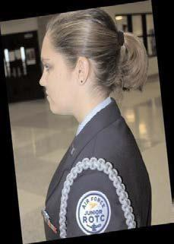
No minimum hair length, to a maximum bulk of 4 inches from scalp and allows proper wear of headgear. Hair will end above the bottom edge of the collar and will not extend below an invisible line drawn parallel to the ground, both front to back and side to side unless pulled back and secured or worn in an authorized ponytail or equivalent or long braid(s). If hair is pulled back and secured behind the head, radius will not exceed 6 inches from the point where the hair is gathered (i.e., no more than 6 inches to the left and 6 inches to the right, 12 inches total width; and 6 inches protruding from where hair is gathered) and must allow for proper wear of headgear. One or two braids or a single ponytail or equivalent may be worn down the member’s back with length not extending below a horizontal line running between the top of each sleeve inseam at the under arm through the shoulder blades. The braid(s) or ponytail or equivalent cannot be worn over the shoulder or pulled in front of the body. They shall extend down the member’s back. Bangs, or side-swiped hair, may touch eyebrows but will not touch or cover eyes. When in doubt, assess the correct length of hair with the cadet standing in the position of attention. Exception: While wearing the Physical Training Gear (PTG), long hair will be secured but may have loose ends and may extend below a horizontal line running between the top of each sleeve inseam at the under arm through the shoulder blades.
Pinned-up hair should be styled in a manner that prevents loose ends from extending upward on the head. When hair is in a bun, the bun must be a single bun; all loose ends must be tucked in and secured. When hair is in a ponytail or equivalent, it must be a single ponytail or equivalent that does not extend below a horizontal line running between the top of each sleeve inseam at the under arm through the shoulder blades.

Locs, braids, twists, micro-braids, French braids, Dutch braids and cornrows

Locs, braids, twists, micro-braids, French braids, Dutch braids and cornrows are authorized. Locs are defined as portions of hair that have been intentionally or unintentionally fused together to form a loc or locs. A braid or twist is two or more portions of interwoven hair. If adding additional hair, it must be a natural-looking color (similar to the individual's hair color) and conservative (moderate, being within reasonable limits; not excessive or extreme). Multiple locs, braids, twists or cornrows may come together down the back in one or two braids or a single ponytail. Hair must not exceed length and bulk standard and headgear must fit properly.

All locs, braids, and twists, when worn, will be of uniform dimension, no wider than one inch, with natural spacing between the locs, braids, and twists and must be tightly interwoven to present a neat, professional, and well-groomed appearance. When worn, multiple locs, braids, or twists shall be of uniform dimension, small in diameter (approximately ¼ inches), show no more than ¼ inch of scalp between the locs, braids, or twists and must be tightly interwoven to present a neat, professional appearance.

A braid/twist must continue to the end of the hair without design and following the contour of the head and may be worn loose or in a secured style within hair standards. Exception: Micro-braids or twists are not required to continue to the end of the hair.

Unauthorized: Mohawk, mullet, or etched design.

Hair accessories

If worn, hair accessories (e.g., fabric scrunches, hairpins, combs, clips, headbands, elastic bands, barrettes, etc.) must match hair color. Black hair accessories are authorized regardless of hair color. Invisible hairnets are authorized; hairnet must match hair color. Hair must still comply with bulk and appearance standards. Headgear must fit properly. Headbands or fabric scrunches will not exceed two-inches in width. Ornaments are not authorized (i.e., ribbons, beads, jeweled pins).

Fingernails
If worn by females, nail polish will be a single color that does not detract from the uniform, nor can the nail polish be extreme in color. Some examples of extreme colors include, but are not limited to, purple, gold, blue, black, bright (fire engine) red and florescent colors. Do not apply designs to nails or apply two-tone or multi-tone colors; however, white-tip French manicures are authorized. Fingernails must not exceed ¼ inch in length beyond the tip of the finger and must be clean and well groomed. Fingernails must not interfere with the performance of assigned duties. Fingernails must not hinder proper fit of prescribed safety equipment or uniform items

Earrings
Male cadets are not authorized to wear earrings while in uniform. Female cadets may wear small (not exceeding six mm in diameter) conservative (moderate, being within reasonable limits; not excessive or extreme) round or square white diamond, gold, white pearl, or silver earrings as a set with any uniform combination. If member has multiple holes, only one set of earrings are authorized to be worn in uniform and will be worn in the lower earlobes. Earrings will match and fit tightly without extending below the earlobe unless the piece extending is the connecting band on clip earrings. When not wearing earrings, male and female cadets are authorized to wear transparent piercing spacer(s) in lower earlobes while in uniform. Transparent spacers are not allowed in ear holes outside of the lower earlobes or any other piercing holes visible in uniform (nose, lip, eyebrow etc.). Piercing holes will not be large enough to permit light to shine through.

Body Piercing/Ornamentation
In uniform with the exception of earrings for women, all members are prohibited from attaching, affixing, or displaying objects, articles, jewelry, or ornamentation to or through the ear, nose, tongue, eyebrows, lips, or any exposed body part (includes visible through the uniform).
Plugs for gauge holes in the ear lobes are not authorized (regardless of color, i.e., flesh colored). There are no exceptions per AFI 36-2903.
Dental ornamentation: Teeth, whether natural, capped, or veneered, will not be ornamented with designs, jewels, initials, etc. The use of yellow gold, white gold, or platinum caps (permanent or temporary) merely to add ornamentation to the teeth and not required by dental/medical necessity is prohibited.
Back to Table of Contents

Figure 3.2. Female Hair Standards
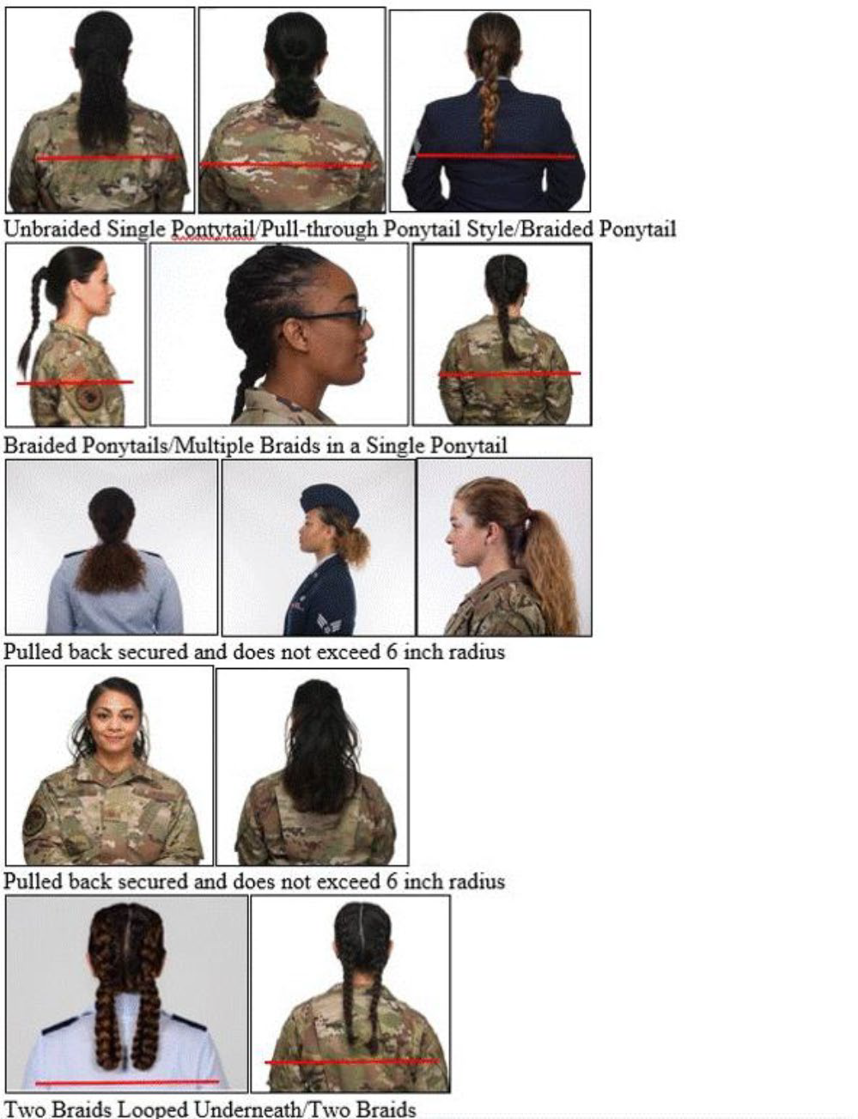
Figure 3.3. Unauthorized female Ponytail Examples.
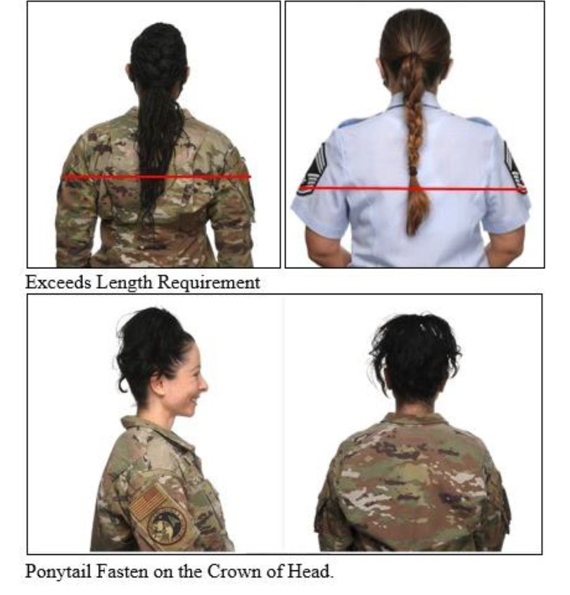 Back to Table of Contents

Specific Male Cadet Grooming Guidelines

Hair-Male. Tapered appearance on both sides and the back of the head, both with and without headgear. A tapered appearance is one that when viewed from any angle outlines the member's hair so that it conforms to the shape of the head, curving inward to the natural termination point without eccentric directional flow, twists or spiking. A block-cut is permitted with tapered appearance. Hair will not exceed 2 ½ inches in bulk, regardless of length and ¼ inch at natural termination point; allowing only closely cut or shaved hair on the back of the neck to touch the collar. Hair will not protrude under the front band of headgear. Cleanly shaven heads, military high-and-tight or flattop cuts are authorized. Prohibited examples (not all- inclusive) are Mohawk, mullet, cornrows, dreadlocks, or etched shapes and/or design. Cadets may have one (cut, clipped or shaved) front to back, straight-line part, not slanted or curved, on either side of their head, above the temple. Part will not exceed 4 inches length or ¼ inch width. Men are not authorized hair extensions. See Figure 3.1
Figure 3.1
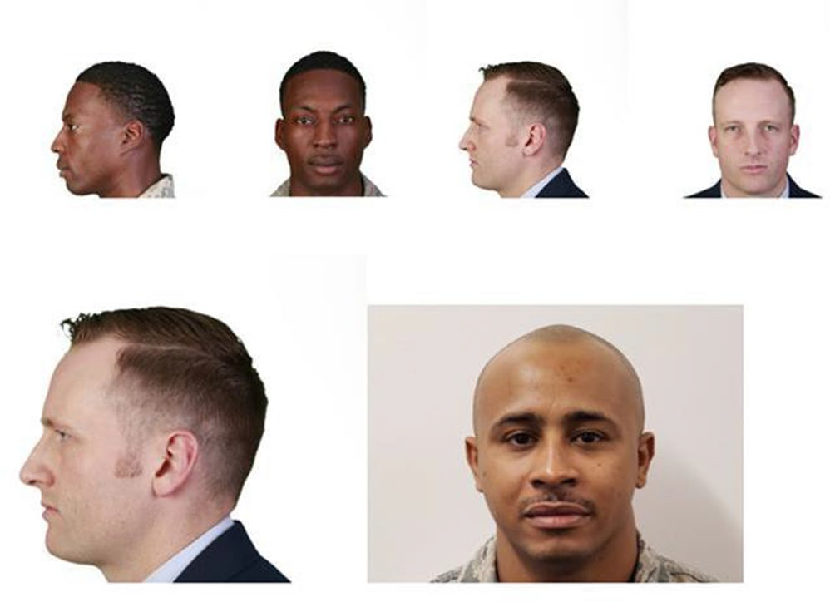

Mustaches
Male Cadets may have mustaches; however, they will be conservative (moderate, being within reasonable limits; not excessive or extreme) and will not extend downward beyond the lip line of the upper lip or extend sideways beyond a vertical line drawn upward from both corners of the mouth. See Figure 3.1

Beards
Beards are not authorized unless for medical reasons, when authorized by a medical official, or as authorized pursuant to a request for a religious accommodation. Beard wear authorized for religious reasons is governed by AFJROTCI 36-2001. When authorized for medical reasons, members will keep all facial hair trimmed not to exceed ¼ inch in length. Individuals granted a shaving waiver may shave or trim their facial hair to present a neat, clean, professional image.

Sideburns
If worn, sideburns will be straight and even width (not flared); and will not extend below the bottom of the orifice of the ear opening. Sideburns will end in a clean-shaven horizontal line. See Figure 3.1

Fingernails
Male Cadets are not authorized to wear nail polish.

Cosmetics
Male Cadets are not authorized to wear cosmetics.

Undergarments (Mandatory)
Appropriate undergarments are required to be worn with all uniform combinations. Wear an undershirt and underpants with all uniforms. Wear the white V-neck or athletic style tank top undershirt when wearing opened collar service uniforms only. Undershirt will be tucked into trousers. Undershirts will not have pockets.

Uniform wear rubric


Cadets are graded using the above chart. Instructors model proper wear of the uniform for cadets the day prior to uniform wear day. In addition, cadets are given written/verbal guidance on which uniform combination to wear at least two days in advance. Back to Table of Contents

Section 4: Wellness / Physical Training (PT):

The Physical Training/Wellness portion includes fitness training, individual and team sports skills, and stretching activities every week on Fridays focused on the goal of improving physical fitness. Sessions include running/walking, stretching and calisthenics. A fitness uniform consisting of Air Force Physical Training (AFPT) gray T-shirt/Sweatshirt and blue shorts and gray sweatpants will be issued to cadets for wear during these activities. The AFPT shirt must be tucked into the shorts/sweats. Wear of the PT uniform consists of 20% of the wellness grade (exception: first-year cadets who opt out of the uniform wear requirements) and is required to be worn on Friday, PT day, to earn a complete PT grade (students who opt out of uniform wear will be exempted from this grade requirement).
A Cadet Participation Consent Form and Health Screening Questionnaire will be sent home for parental review and signature and must be returned prior to participation in fitness activities. Additionally, a parental consent form to allow cadet entry of student physical performance metrics/event participation as well as permission to photograph students will be sent home for signature. Back to Table of Contents

Section 5: Program Opportunities & Leadership Development Requirements (LDR) Activities

LDR activities are what make our corps more successful. They add interest and prestige to the program while helping cadets to meet a variety of people, from classmates to members of the community. Involvement in LDR activities strengthens cadet character, develops valuable skills, and demonstrates responsibility for future staff positions. Each cadet is encouraged to find and or suggest activities that interest him/her to do their best. Back to Table of Contents

What a typical week of LDR activities at NC-944 looks like:

At the beginning and end of each school day: Flag Detail Team – The Flag Detail Team is dedicated to raising and lowering our US and NC flags daily. The Flag Team consists of both current and reserve cadets. Wear of the uniform is not required to conduct this activity. Cadets are trained in flag etiquette and are expected to perform this duty with the utmost of respect. Cadets who perform a minimum of three hours of flag detail will earn the Patriotic Flag ribbon.

Wednesday: Color Guard and/or Drill Team - A color guard team consists of a minimum of four cadets carrying replica rifles and one U.S and one NC flag. The commander always holds the US flag. The team marches shoulder to shoulder and performs very precise movements at NHS sporting events and a variety of other community events which require posting of the colors. Color Guard practices are held on Wednesdays during the designated time (intervention period) scheduled for NHS clubs to meet (currently 2:04-2:54 PM). Color Guard members are eligible to earn the color guard ribbon. A drill team may also be sponsored (as cadet interest warrants) and would be fielded to perform a series of movements at drill competitions and other events requiring a team to perform.

Friday: Community Beautification Team - The beautification team has a mission to ensure our school and the surrounding area remains clean and tidy. The beautification team removes trash and debris from the NHS sports fields to the main bus lot. These areas require attention resulting from NHS students’ eating and recreation activities. This activity is normally scheduled once per month at a minimum during the scheduled Fitness class period. Back to Table of Contents

Additional LDR activities:

Recruiting – In order to ensure minimum required enrollment, recruiting activities take place during the school year beginning with Freshman orientation in August, and continuing throughout the year with lunchtime recruiting events. Additionally, cadets on the recruiting team assist with NHS open houses and curriculum fairs, as well as on-site visits at feeder middle schools during registration fairs (as requested). During the various events hosted, cadets inform potential AFJROTC students about the Service Dress/ABUs/PT gear, the new opt-out option for first-year students, how AFJROTC can affect their lives after high school, as well as all the unique experiences the corps has to offer. Cadets participating in recruitment activities are eligible to earn the recruiting ribbon.

Community Service Activities: In previous years, cadets also volunteered time to organizations such as, Habitat for Humanity and Durham Rescue Mission. Activities included serving meals at the men’s and women campus, and weather permitting, volunteering to build homes for Habitat for Humanity. Cadets also participated in a community service project called “Pennies for Patients” to help support the Leukemia and Lymphoma Society.

APT Team (Future/Optional Activity): The Awareness Presentation Team (APT) is an academic endeavor designed to provide positive role models for elementary and middle school students. The APT covers topics such as peer pressure, conflict resolution, sexual issues, violence, and drug & alcohol awareness, peer pressure, and gang violence.

Air Force JROTC Academic Bowl (NC-944 has participated since SY 2020): The College Options Foundation sponsors and is dedicated to enriching the academic development of high school students and assisting them in their preparation for higher education. All cadets will be given an opportunity to complete the online practice test. Following a selection process, qualified students will be able to, as a team, participate in competitions. Cadets who participate in the Academic Bowl as a team may win the opportunity to compete in the Academic Championship (JLAB) in Washington, DC! Sixteen AFJROTC teams will qualify to attend the National Championship. There are many benefits of participating in the Academic Bowl:
- Improve SAT/ACT scores
- Increase interest in college admissions
- Demonstrate academic strength of JROTC program
- Boost esprit de corps
- Earn the opportunity to travel to our nation’s capital

Kitty Hawk Air Society (KHAS) (Future/Optional Activity): KHAS is the academic honor society of AFJROTC that promotes high academic standards, school and community service, self-confidence, and initiative along with leadership abilities, academic excellence and furthers members’ knowledge in aerospace. KHAS provides additional areas for leadership experiences and development. It also provides membership certificates and badges awarded to each qualified cadet.

Model Aircraft and Rocket Club: (Offered based on demand) - Cadets are offered the opportunity to build model aircraft and gain the experience needed to build a top notch model that can be placed in a model competition. Cadets also build rockets and launch them at designated locations. When and if a cadet successfully completes all such tests and launches and recovers his/her rocket three times, he/she will receive the Rocket Badge to be worn on the blue uniform. Back to Table of Contents

Section 6: Planning and Executing Cadet Operations and Programs

Note: Some of the functions described in this section may not be currently implemented due to the rebuilding of cadet leadership capabilities following COVID-19 pandemic.
Programs in the corps are intended to be cadet initiated, planned, led, executed and documented. This includes social and team functions such as the Military Ball, Air Force Bowl, Curriculum In Action (CIA) trips, fundraisers, and community service projects.

Ideally, at the beginning of each semester the corps commander meets with selected leaders and together the leadership team identifies goals and projects for the year. The corps commander then chooses a leader for each initiative based upon their capability to lead and bring the project to completion.
The flight leaders assist in choosing who will be eligible to go on CIA trips, or attend other AFJROTC functions held by NC-944. Cadets with disciplinary issues may not be eligible to attend field trips. Field trip eligibility is shared with all cadets during the Look Ahead Briefing provided during all class periods. The field trip eligibility criteria are as follows:
- 100% Uniform Wear (exception: cadets who opt out of uniform wear)
- No behavior referrals
- 5 or fewer absences & tardies
- No more than 2 cell phone violations
- Good academic standing

Our leaders are responsible for training their staff. Our corps is structured to facilitate cadet training in leadership and citizenship to the community. Back to Table of Contents

Replica weapons policy

Color Guard-specific requirements include ensuring all rifles are accounted for properly. The SF form 702 is utilized consistently to sign out/return all rifles, if taken off of school grounds. Replica weapons are transported using the green weapons cases at all times.
Additionally, these items must be returned to unit storage daily unless overnight trips (supervised by an AFJROTC instructor) are involved. While transported, these items may not be openly displayed and must be under the control of an instructor. An instructor or cadet must have positive control of the replica weapons, sabers/swords, and/or air rifles at all times prior to, during, or after an event. (Positive control means having hands-on or in a responsible person’s possession) For any events away from campus, these items must be transported under supervision by the instructor. At no time will these items be left unattended. Replica weapons will never be issued to take home.

Cadet Rank, Promotions and Awards

Cadets who wish to gain rank and positions of authority must maintain an acceptable standard of academic achievement, be active in the classroom environment, and AFJROTC LDR activities, encourage a high degree of personal honor, self-reliance and leadership, promote patriotism, and respect constituted authority.

Promotion within NC -944 AFJROTC creates an on-going challenge and motivation for cadets to display integrity in and out of the classroom. Promotion to a higher rank reflects visible evidence of increasing maturity, ability and willingness to accept responsibility, and demonstrated growth in leadership. Additionally, it displays an ability to work with others as a team and capacity to help direct the team toward squadron goals and objectives.
There are four promotion cycles per school year; one following each academic quarter. You may be selected for promotion at the end of the quarter by the instructors and cadet leadership.

All first year cadets (AS1) begin the semester with the rank of Cadet Airman Basic. Cadets will earn advanced rank by:
- Actions/behavior reflecting creed values
- Knowing the creed by heart within one month
- Having a grade no lower than a B in AFJROTC
- LDR activity (Color Guard, Flag Detail, etc.)
- Participating in PT with obvious effort
- Participating in class/class activities
- Demonstrating leadership

Actions that preclude earning rank include:
- Actions/behavior contrary to creed values
- Displaying a poor attitude/apathy
- Spending time in RPC or behavior suspension
- Being disrespectful to classmates or instructors
- Poor PT effort – ex: mile time over 15 minutes; exceptions for cadets on medical profile
- Failure to wear the uniform consistently and unwillingness to improve

Rank may be earned back by CONSISTENTLY avoiding poor behavior.

Minimum rank standards are as follows:
- 2nd year cadets - Cadet Airman
- 3rd year cadets - Cadet Airman First Class
- 4th year cadets - Cadet Senior Airman

Cadets who continue to shine in and out of class are recognized with opportunities to take orientation flights, and are awarded ribbons as appropriate. Back to Table of Contents

Specific Insignia (Rank) Placement

Insignia Placement. Insignia on the AFJROTC uniform will be worn according to the figures contained in this guide. Rank placement guidance is displayed on a bulletin board in the classroom. Common errors associated with incorrect uniform rank and other uniform items such as name tag placement are:
- Using wrong gender uniform guidance to place rank on male/female uniforms
- Using rules for the blue shirt on the blue blazer
- Using rules for zip up jacket on blue shirts
- Using ABU uniform rules on blue uniforms.
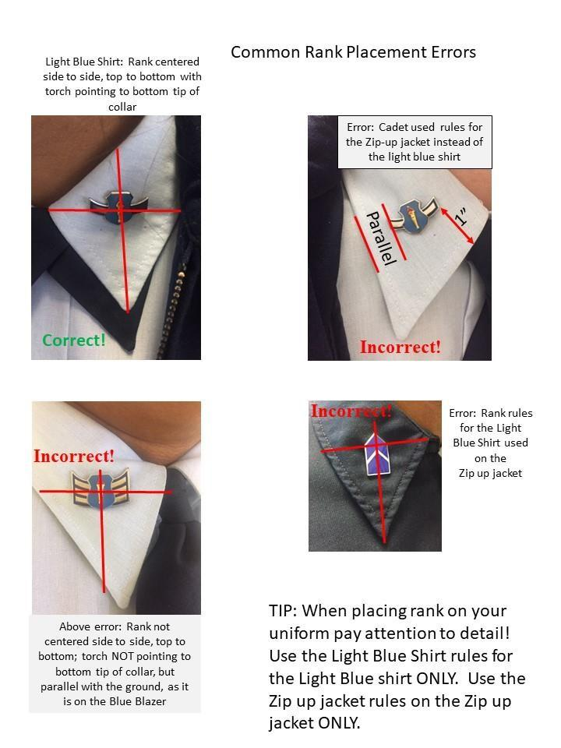

Section 7: Cadet Discipline
Cadets are held to a higher standard than other students in the school population. As the creed states, cadets must always conduct themselves to bring credit to their family, school, Corps of Cadets, community, and to themselves. It is for this reason that cadets whose behavior brings discredit to our corps must understand how their behavior reflects on others, and correct the behavior. Continued refusal to correct poor behavior or to carelessly wear, or failure to wear the uniform respectfully may result in a decision to remove the cadet from the program.

Prohibition on Physical Discipline, Hazing and Unofficial Teams

These prohibitions are applicable to all AFJROTC events, activities, and/or practices. These
prohibitions apply to AFJROTC instructors, AFJROTC cadets, and any other person who may be involved with, coaching, or otherwise participating with cadets, or attending or observing an
AFJROTC event, activity, and/or practice.

No person will encourage, allow, or condone the use of any type of physical act or abuse
as an outcome, punishment, penalty, or corrective training for a cadet’s failure to achieve a
specific result. These prohibitions include, but are not limited to physical exercises, menial
tasks (e.g., cleaning bathrooms), or any physical exchange such as shoving, pulling, or hitting.

No person will encourage, allow, or condone the use any type of psychological abuse
as an outcome, punishment, penalty, or corrective training for a cadet’s failure to achieve a
specific result. These prohibitions include, but are not limited to any effort to humiliate, tease,
intimidate, or publicly reprimand or embarrass a cadet for failure to achieve a specific result.

No person will encourage, allow, or condone the use of any form of hazing, whether
physical or psychological, within any AFJROTC event, activity and/or practice. All persons
involved will ensure any membership requirements or qualifications to join any approved
AFJROTC team, event, or activity does not include anything humiliating, demeaning, or
otherwise unapproved by this instruction.

No person will encourage, allow, or condone the use of any device, gimmick, or game
to select an outcome, punishment, penalty, or corrective training for a cadet’s failure to achieve
a specific result.

Unofficial groups, secret societies, private clubs, or any other unofficial entity within
an AFJROTC program is prohibited. Back to Table of Contents

Section 8: Corps Excellence

NC-944 should be regarded by faculty and students as the best student organization on campus. Our LDR activities such as Color Guard/Drill Team participate in community events within and outside of NHS, including cooperative/joint efforts with other school organizations, clubs, and programs. A complete list and description of LDR activities was covered earlier in the section
“What a typical week in NC-944 looks like” and “Additional LDR activities”

Academic success is a high priority for cadets and factored into awards, promotions and job advancement.

Within our Health and Wellness Program, physical fitness calisthenics are usually led by cadets for each flight. These cadets plan/lead the class exercises. PT leaders may also document cadet performance and assess the progress of each cadet. Program modifications may be made to improve cadet weaknesses.

Cadets are encouraged to be active participants in other student organizations. The goal of NC-944 is to challenge our cadets to be well rounded.

NC-944 cadets take pride in our established unit. Cadets are actively involved in keeping the AFJROTC area clean and neatly organized consistently. We encourage our leaders to keep work areas neat, organized, and up-to-date. Additionally, we decorate the classroom to exemplify our patriotism.

On-line access via the Canvas Learning Platform is available to all cadets. The latest version of Cadet Operations Guide, Chapter 7, dated 1 Sep 2023 is posted as a reference to Canvas Files for all AS classes. Additionally, the AFJROTC NC-944 Reference Guide is available to all cadets via the NHS website and may be accessed at the Special NHS Program link. Refer to Attachment 6 for grooming standards for Females and for Males

After Action Reports (AAR)

To ensure continued improvement, LDR activity leaders are expected to generate an After
Action Report (AAR) upon completion of LDR Community Service activities. The AAR will contain a “bottom line up front”, what went right, what went wrong, “what should be done differently" and “the way forward”. The AAR, when done correctly should reduce the amount of errors that are repeated during LDR activities and focus LDR activities toward continuous improvement as opposed to merely conducting activities. As an example, the Color Guard marched onto the field of play and presented the colors in reverse order. Because of that, new procedures were developed to ensure the flags would be presented in the proper order at all times. Back to Table of Contents

Section 9: Reserve Cadets

Reserve cadets are cadets who cannot enroll in AFJROTC courses within the school and are in the AFJROTC program for the sole purpose of participating in co-curricular (after school) activities. To qualify as a Reserve Cadet, a student will meet one of the following criteria, with SASI concurrence:
- The student has completed the entire AFJROTC Academic Program at the school and cannot continue without duplicating curriculum courses.
- The student is currently enrolled in a 4x4 scheduled unit, has completed an AFJROTC course during the first semester, but is not participating in an AFJROTC course during the second semester. In some cases, a student has been enrolled in AFJROTC classes during the previous school year but was unable to schedule an AFJROTC class until the second semester of the following school year. The SASI will also give consideration to these students for Reserve cadet status on a case-by-case basis.
- • A student must have been a cadet for at least one semester prior to being considered a Reserve Cadet.
Reserve Cadets may participate in all AFJROTC activities (community service, drill team, honor guard, etc.). Time in reserve status does not count towards the Certificate of Completion, nor do Reserve Cadets count toward minimum unit enrollment or unit funding. Reserve Cadets may retain their uniform for the entire academic year.

Section 10: Cell Phone Policy

AFJROTC does not allow Cadets to use cell phones/electronic devices in the classroom unless specific permission is given by instructors. Cadets are advised to place cell phones in their bookbags for the following reasons:
- “Phones out of sight” is DPS policy!
- A school provided laptops are the preferred tool to use during classroom instruction.
- Cell phones/electronic devices are a distraction to students, their peers and the education process.
- Storing phones/electronic devices in the cadet’s own backpack ensures phones/devices are SAFE from theft or misuse.
- Excessive cell phone/electronic device violations can prevent a cadet from field trip attendance.
- If you are caught using the phone/electronic device, it is considered a violation of school policy. Back to Table of Contents

Attachment 1: Cadet ABU Guidance
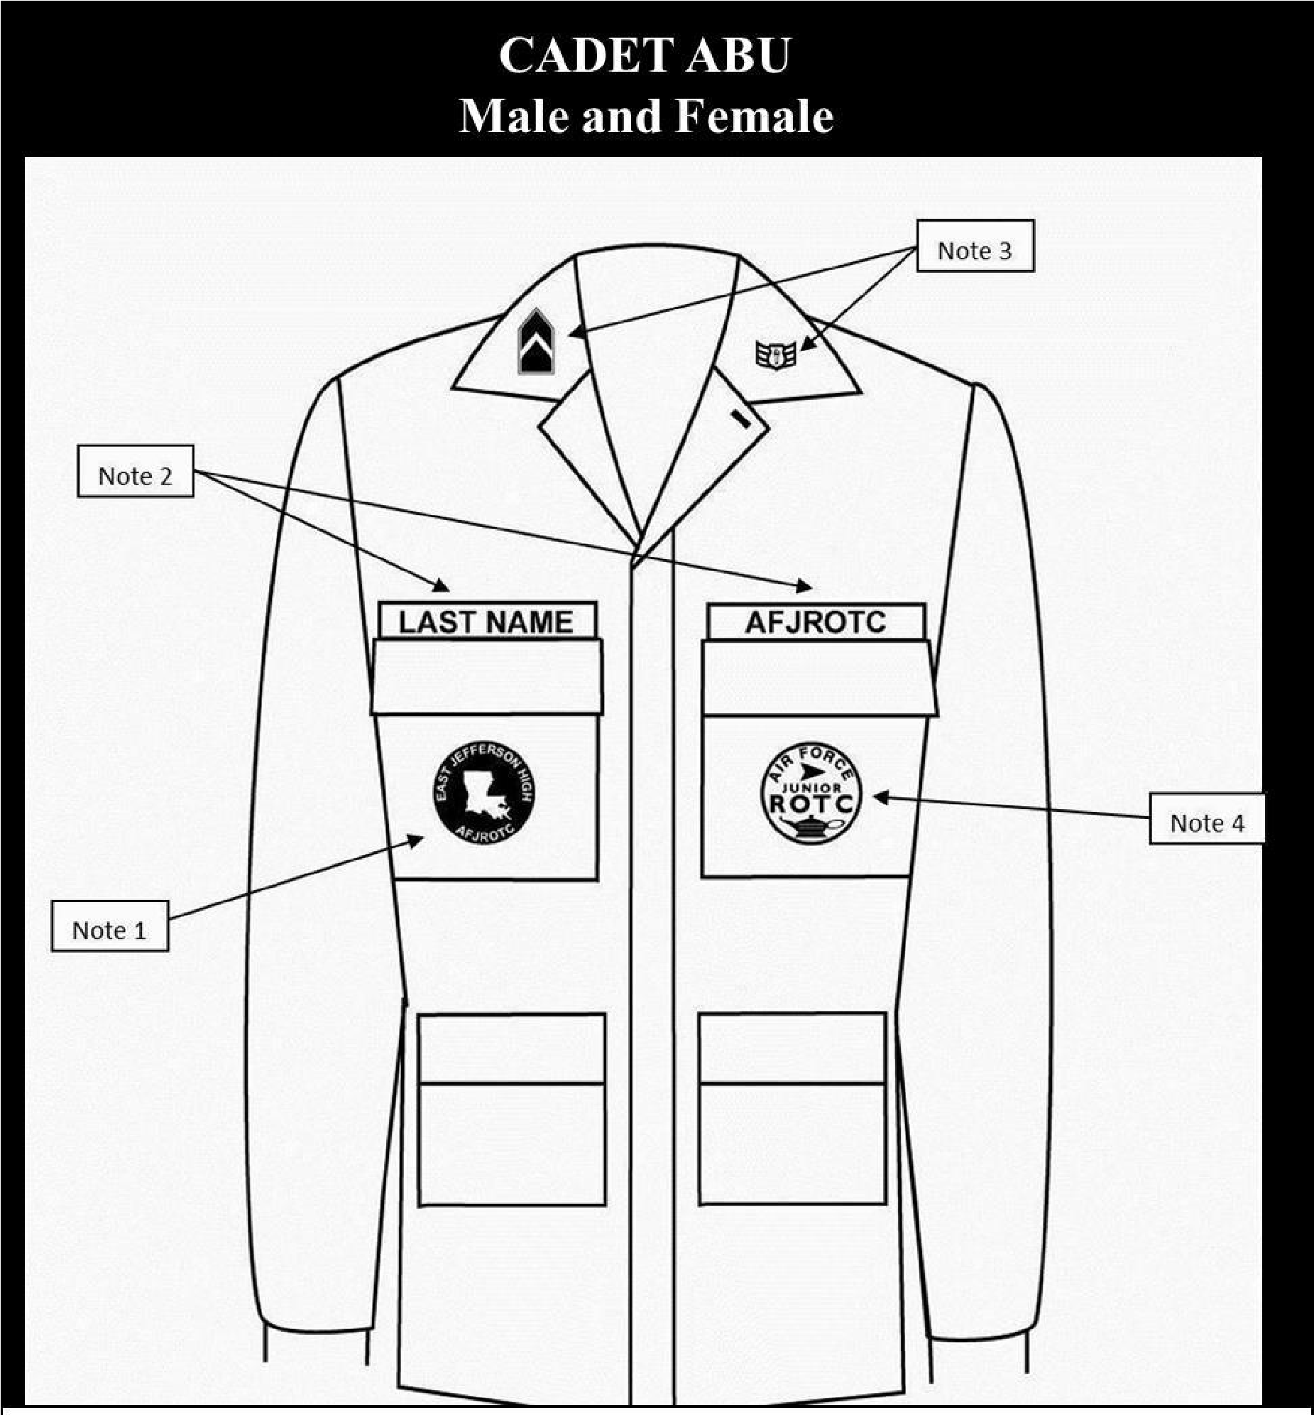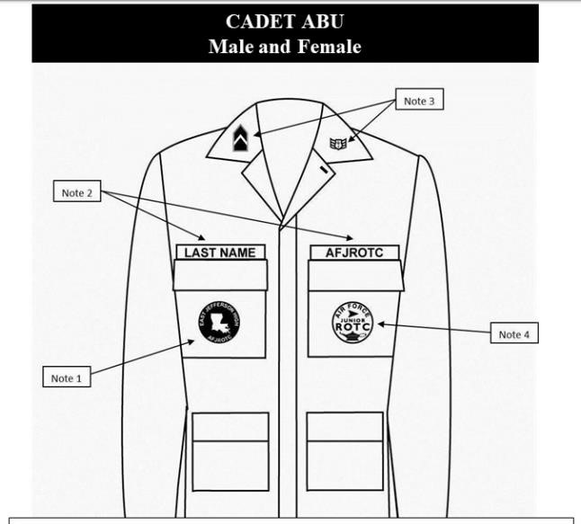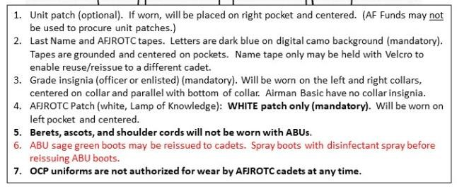

Back to Table of Contents

Attachment 2: Lightweight Blue Jacket
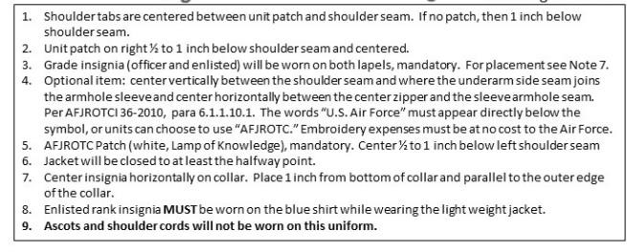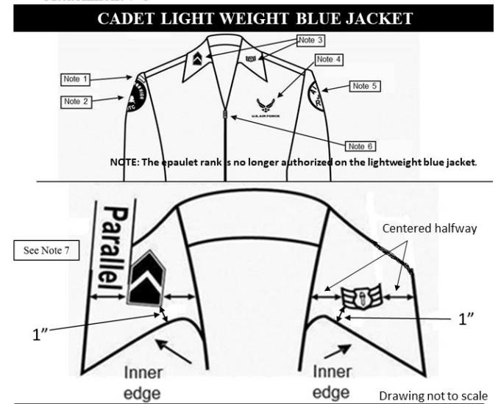

Attachment 3: Male Service Dress
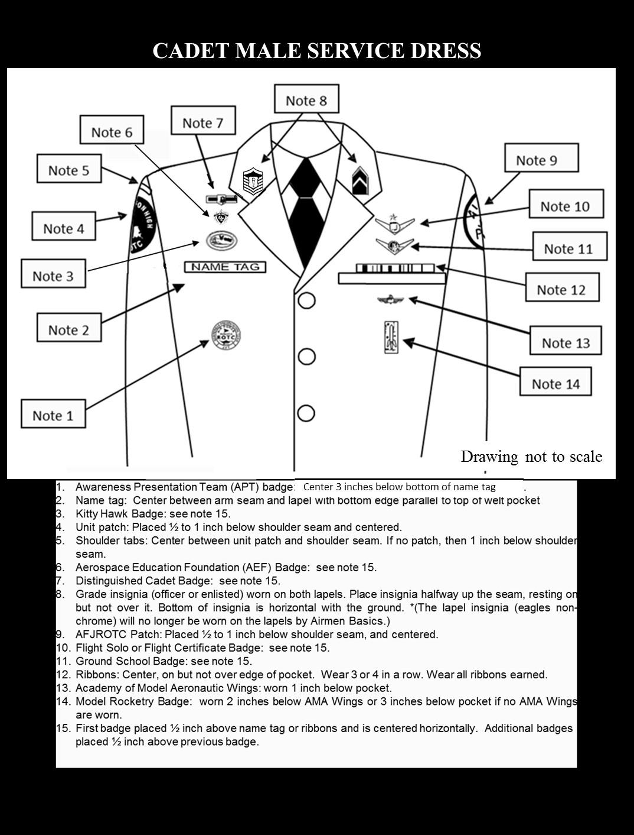
Back to Table of Contents

Attachment 4: Female Service Dress
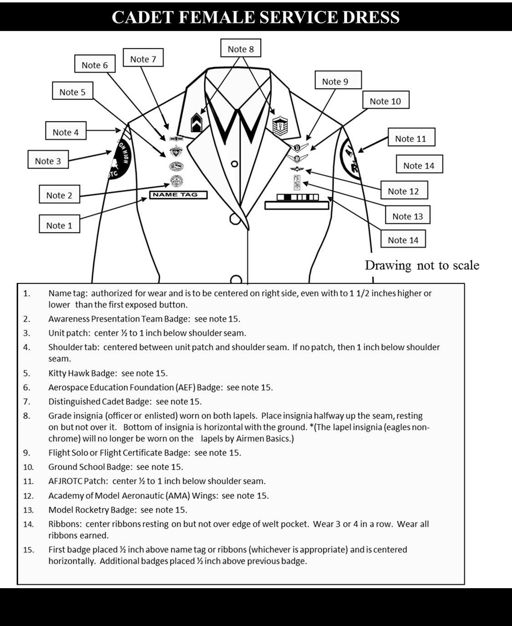
Back to Table of Contents

Attachment 5: Male Blue Shirt
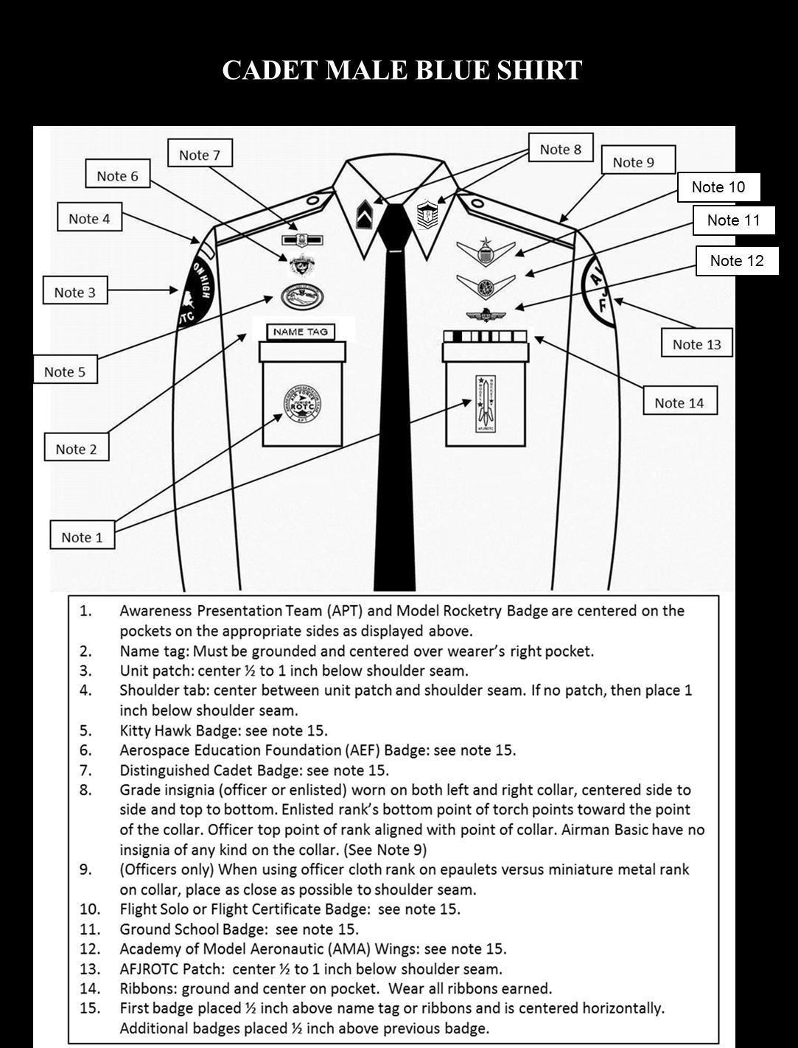
Back to Table of Contents

Attachment 6: Female Blue Shirt

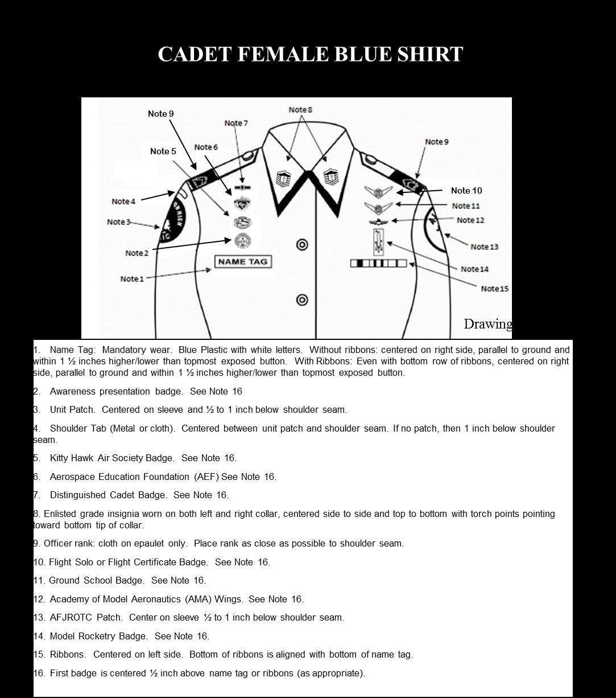
Back to Table of Contents

Attachment 7 AFJROTC Ribbon Chart
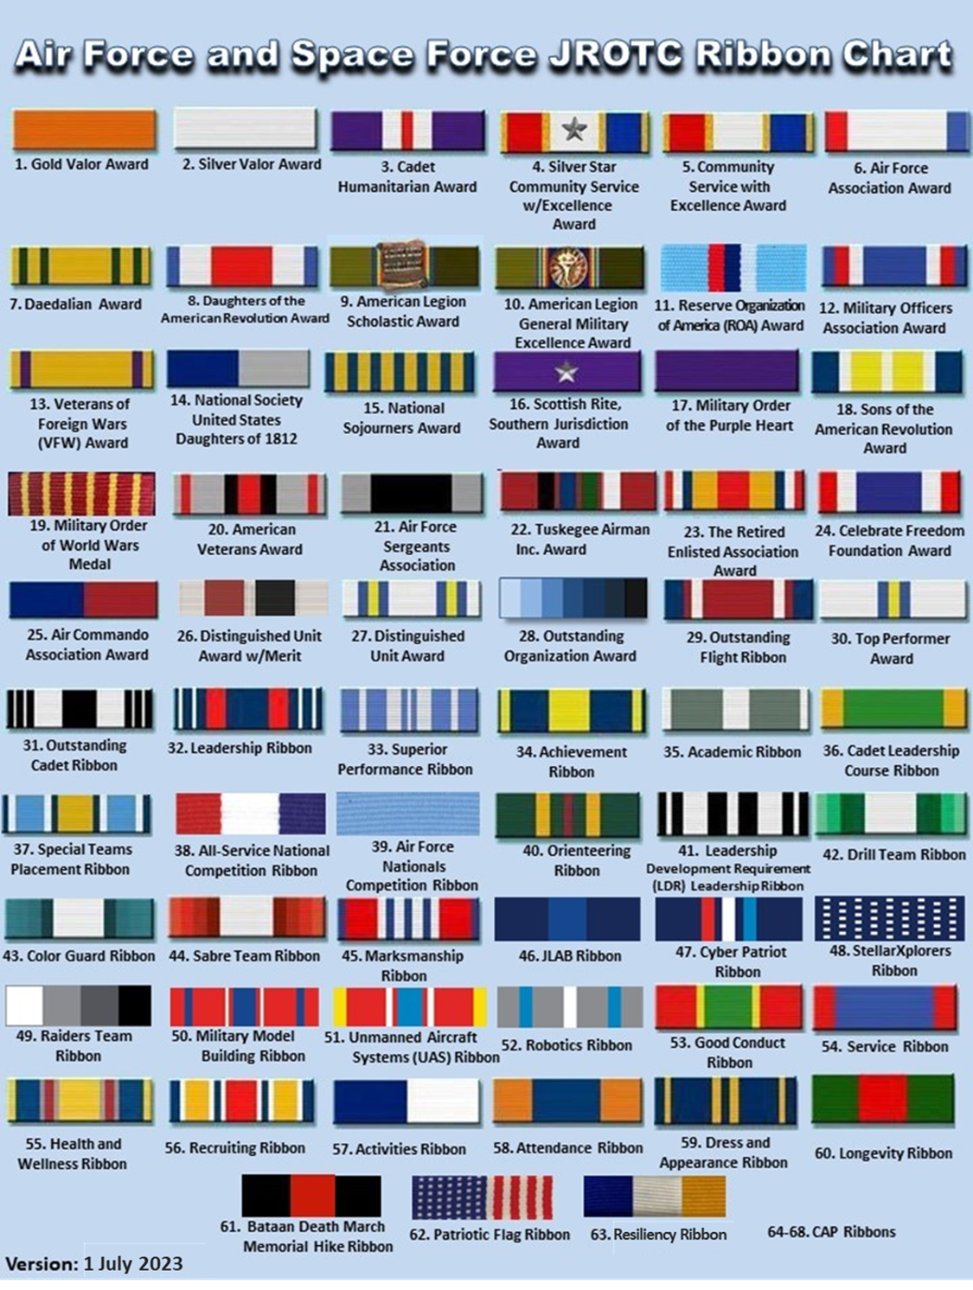

Attachment 8: Shoulder Cord Policy
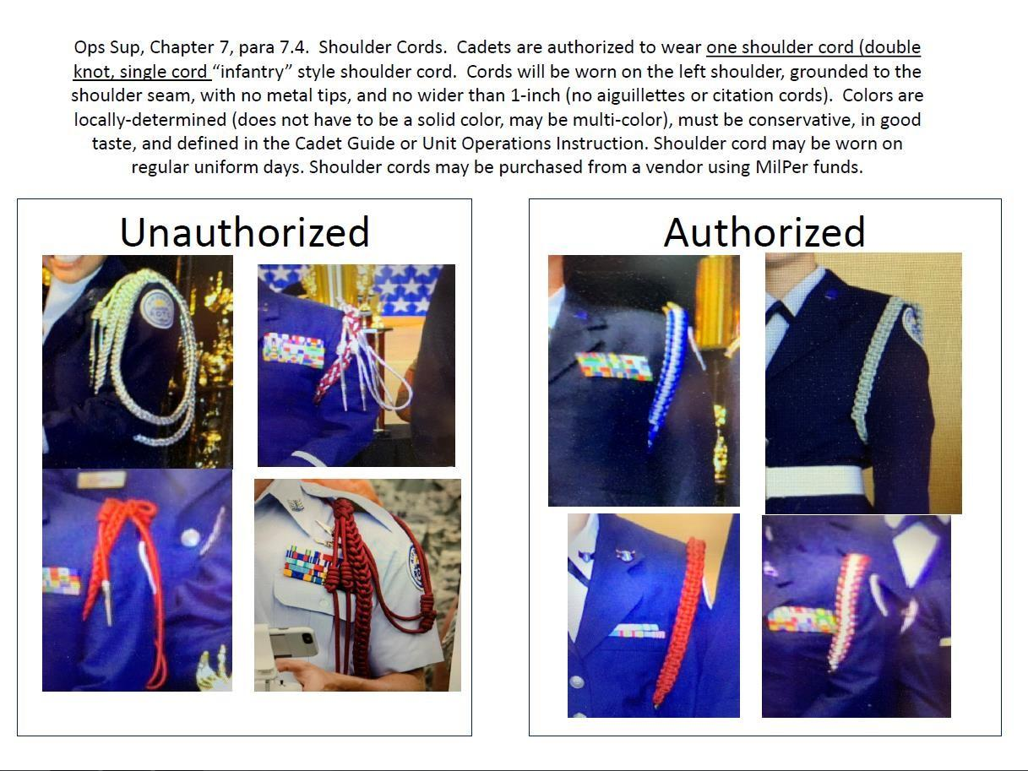

Cord Colors:
Red: Corps Commander
YELLOW: COLOR GUARD
White: Color Guard Commander
Black: Drill Team
Blue/YELLOW: Element Leaders
GOLD: Flight Commanders

